Jefferson County Community Read
Agenda
December 3, 2020

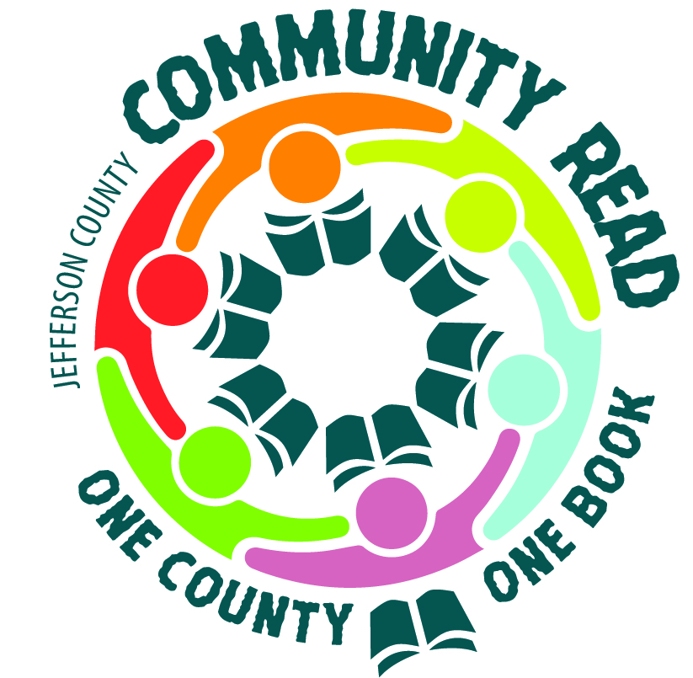

1. Call to Order
2. Election of officers
3. 2021 Community Read Book Selection
4. Next Steps
5. Adjournment

