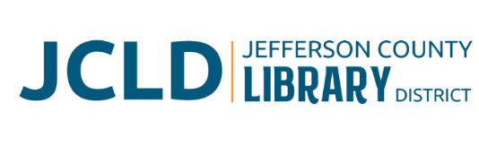
BOARD OF DIRECTORS MEETING
Monday, December 9, 2025 @ 4:30 pm
241 SE 7th St, Madras, OR 97741

Agenda
- Call to Order
- Acceptance of Agenda and Establishment of a Quorum
- Public Comment
- Presentations
- Audit report from Sorren CPA
- Review/Approval of Minutes
- November 10, 2025 Board Meeting
- Finance Report
- Monthly financials as of November 30, 2025
- Old Business
- Update on Building expansion project
- Update on Culver partnership project
- New Business
- Policy Monitoring
    - Governance: Board Committee Principles
    - Executive Limitations: Communication and Support to the Board
- Library Activities Report and Update

- Ending Remarks

- Adjourn

