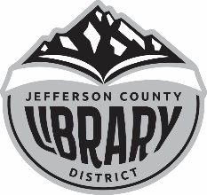
Need to use a computer?
The Jefferson County Library can help!

- During the hours when Library staff is available, 10 am – 3 pm, M-F, call (541.475.3351) to set up a time to use one of the Library’s computers.
- A member of the Library staff will confirm a time with you. Right now, there is a 30-minute limit per session.
- If you don’t already have a library card, we have guest passes available. If you’d like to take full advantage of all of the resources available to you through the Library we can set you up with a JCLD library card while you’re using the computer.
Open to all ▪ Information is free
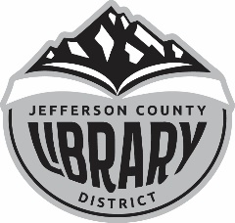
Need to use a computer?
The Jefferson County Library can help!

- During the hours when Library staff is available, 10 am – 3 pm, M-F, call (541.475.3351) to set up a time to use one of the Library’s computers.
- A member of the Library staff will confirm a time with you. Right now, there is a 30-minute limit per session.
- If you don’t already have a library card, we have guest passes available. If you’d like to take full advantage of all of the resources available to you through the Library we can set you up with a JCLD library card while you’re using the computer.
Open to all ▪ Information is free
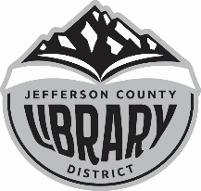
Need to use a computer?
The Jefferson County Library can help!
- During the hours when Library staff is available, 10 am – 3 pm, M-F, call (541.475.3351) to set up a time to use one of the Library’s computers.
- A member of the Library staff will confirm a time with you. Right now, there is a 30-minute limit per session.
- If you don’t already have a library card, we have guest passes available. If you’d like to take full advantage of all of the resources available to you through the Library we can set you up with a JCLD library card while you’re using the computer.
Open to all ▪ Information is free

