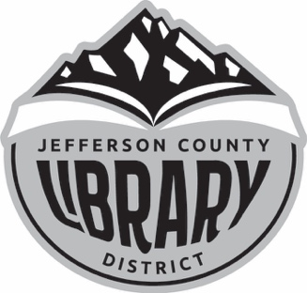
June 2020
Director’s Report
Department Reports

Reporting on May 2020 Activities

Director’s Report
Staff and Facilities
The staff used the 2-month Library closure to work on some housekeeping projects, prepare for the Summer Reading Program, re-arrange the Circulation area, and create content for the new Web site. Painting is almost finished (back dropbox and a few other things remaining.) They volunteered during the Memorial Day weekend and moved the Circulation Desk away from the center of the building, toward the Youth Services section. In preparation for a limited opening beginning May 26, we added more signage.
Tri-County Meetings
Laura and I have been attending the weekly Tri-County meetings via Zoom. The discussions have focused on safety precautions, coordinating the timetable for reopening, including resuming courier services, allowing customer holds, and other catalog features, and updating additional technical information. If you remember, we converted from the Classic Catalog to the Encore Catalog in March.
Budget Preparation
May focused on budget-related activities, with meeting scheduling, legal postings, and final budget preparation. The Budget Committee met May 12 via Zoom and reviewed the initial numbers. Committee members offered suggestions, and the budget was revised in preparation for a June 3 follow-up meeting. The Services Departments consolidated and recommended its materials and programming budget, which included reorganizing the line item numbers to make them more consistent across sub-categories. I realized that the Library has been paying for the ORBIS Courier (inter-library loan materials) and the Tri-County Courier (running between DPL, CCL, and JCLD). After talking with Jackie, we agreed to cancel the ORBIS courier effective July 1. The per-item cost calculated at around $12.00; USPS costs about $4.00 per item. I am reviewing our ILL policies with Jackie; USPS is closer to $4/item. CCL and DPL shared their ILL policies, and I'll be clarifying our policy and procedure.
Website
The new JCLD website will launch June 1, in time for online Summer Reading Program registration. All of the departments have been working on preparing and posting content. Departments are responsible for maintaining their areas. We can create online forms that replace paper ones. Focused maintenance is required for the site to ensure that links are working, and content is up-to-date. The Web site is like the final phase of the Library facelift. Well, outdoor signage is still pending, as is the logo for the wall behind what is now the Circulation area.
Job Descriptions and Circulation Policies
I've been reviewing circulation policies (first) as time allows. The staff has received basic job descriptions; they have considered them, and I'll be reviewing them. Individual mentoring meetings will occur planned the last week in June.
Outreach and Marketing
The Chamber Cheer! featured the Library on the May 26. The Chamber staff visited the Library to film an update on activities and facilities. The video is available on the Chamber site and the Library's Facebook site. Logos outside the Main Library, Genealogy Center, and Annex are next.
Other
I've scheduled vacation the week of June 15. A reminder that the Budget Hearing and Special Board Meeting are scheduled for June 23, 2020, at 3:00 pm, and 3:15 pm, respectively.

Department Reports

Adult Services/Community Services (Gabby & Gretchen)
We have started the Adult Summer Reading program. All the information is included on the Library website that publishes in the June 3 edition of the Madras Pioneer. (Library looks great, by the way.) Gretchen is meeting with the Metolius Town Council to discuss the Little Free Libraries, and the Council is considering building one. Because of the limitations related to social distancing, most programs have shifted to online. The Online Book Club is available via the Library's Facebook page. The June theme will romance. Now that stores are reopening,
The team is working on the Book Walk for the Summer Reading Program (SRP), and we’re hoping to include Culver and Metolius.
Gretchen is visiting local businesses to say "Hello" and remind everyone the Library is open again. She scheduled the May Chamber event. On the 26th, the Library was showcased on their weekly Chamber Cheer! It went well, once the sound was connected.
Friends of Jefferson County Library has a full board and updated bylaws. Since the President resigned a few months ago, the treasurer was the only active officer. Recruitment efforts were successful. The goal is to return the organization and activities to the Friends. Twice Read Books is opening more frequently. FoJCL is having a paperback sale on June 13.

Circulation Statistics – Alex
(Also in the Smartsheet)

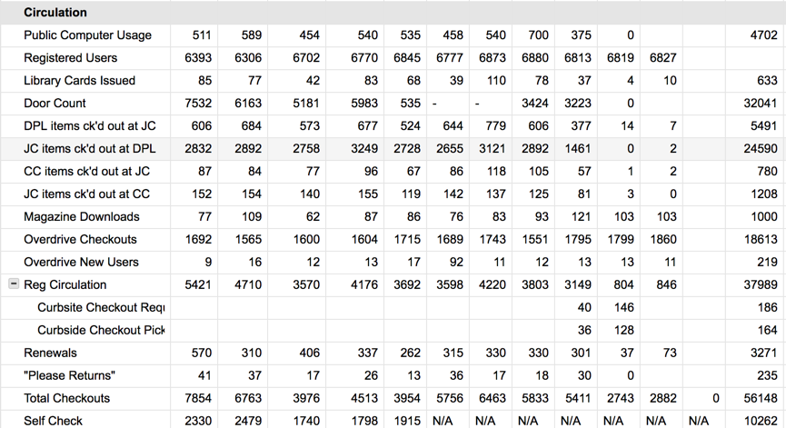

Curbside Statistics/Volunteers - Swan

We are not accepting volunteers at the Library yet. Browsing and computer use started 5/26.
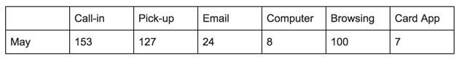
Cataloging/ ILL - Jackie
Interlibrary loans (ILL) have been temporarily halted in the last few months, because of the COVID19. Most libraries have been closed, along with some courier systems. Our contract with the tri-state ORBIS courier system, which we have been using for some years, will end at the end of June. The courier allows us to borrow and return items in cloth bags on a set contract basis, not per piece, and avoid many trips to the post office. We contracted a twice a week service for pickups and deliveries.
The expenses related to using the service have increased, and the annual fees were probably rising to around $4500 in 2020-21. Our ILL requests have decreased over the years. The next step is to contact Stamps.com, for postage and stamp services. It should work out just fine with a bit of an adjustment for learning the use.
If we have our packages ready to go with postage attached, that should save trips to the post office and allow the mail carriers to regularly pick them up from the Library. I think this will work out quite well.
Items were withdrawn in May, duplicate copies no longer needed, non-circulating items, or items in poor condition; 274 items removed. Most of the books removed were in the adult fiction and nonfiction sections; only a few were Juvenile books.
Bib records added: 120
Withdrawn items: 274
Materials added: 432

Safety Committee - Swan
When we started thinking about reopening, the Safety Committee (Gabby, Star, Swan) reconvened. The committee met in May to finalize reopening procedures that adhere to the OHA guidelines. A follow-up meeting occurred on June 1 when all decided to add a bell to the front door and to keep it unlocked. The bell will reduce staff attention to the door; so far, the maximum occupancy has not been reached; we haven't had to turn people away. If the maximum occupancy is reached, the front doors will be locked.
Computer use will be restricted to appointments first, and then first-come, first-served—equipment sanitizing occurs after each appointment.

Youth Services – Adriana, Laura, Star
Online Programs
Online Storytime for May was a learning experience. All of us became directors, cameramen, editors, gaffers, and more as we developed the skills required for producing online videos. Hopefully, we have all learned from our mistakes, and our video quality is improving. According to our stats, Bilingual and Spanish storytime continues to be our most-viewed programs. Starting in June, we will only provide Bilingual storytime for the summer. Please take the time to view our videos! Our Traveling Storyteller, Star Todd, also began reading a book for every Monday morning. We had a video publishing every day except for Wednesday and Sunday. She had the top watched video on YouTube for her Go Away Big Green Monster!
Teen Programs
The Dungeons & Dragons session was once again held online. There will be one more session in June and then break for the summer. The April meeting was held via Zoom, but this time we used a Virtual TableTop to hold the session that is for role-playing games online. The site is called Roll20 and worked well.

Summer Reading Program (SRP)
Much work has gone to working with the school district to establish a protocol for giving out kits at the free lunch sites. The school districts are favorable to the idea but a little hard to catch on the phone. Times and locations are set with just a few kinks left to work out.
The giveaway books have been stickered to recognize the Jefferson County Cultural Coalition for the money that made them possible. Kits are being assembled.
The weekly challenge will be for registering for the Summer Reading Program online. Registering is new this year. It will be for statistical purposes that will aid our Library and the State library by creating a picture of who is reached and served with this program. Registration is on our new website that launched on June 1. SRP information is available in English and Spanish on the new website.
Youth Services and Community Services met with Sue Matters at KWSO at their location to work on a radio storytime segment at 7:10 am during July and August. Gretchen and Gena recorded along with two Warm Springs teachers, a husband-and-wife team. Star, Laura, and one more Warm Springs teacher, Sara Bennett, will record the first Friday in June. KWSO will edit the audio and air the program in July and August and make them available as podcasts available for their website and ours.

