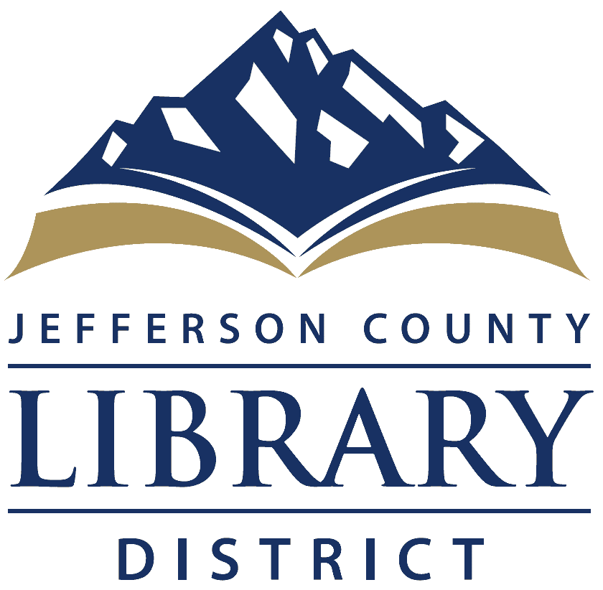
Director’s Report July 2019
This Director’s Report is an abbreviated one. I’ve met all of the staff and board members. I’ll be scheduling individual meetings with each staff person. Received correspondence from the Jefferson County Sheriff’s Office about donated books for the JeffCo Jail. After talking to Judy Ogara (the incoming Friends of the Library coordinator) we’re offering any books remaining to the jail for pickup on or after August 2, 2019 at 3 pm.
Internet/Phone. We changed Internet Service Providers. After the 30 transfer period the former company cut service and due to a communication snafu, no updated IP addresses were provided. Since the JCLD has Internet phones, the phones went down. This also has repercussions for our IP address with Deschutes Public Library. CMIT is working with the appropriate representatives to resolve the situation. At this time, the situation is set to be corrected on Thursday 11 July 2019. Until then, the library phones are not working.
Signature changeover has occurred for bank accounts, county clerk, SDAO. A representative from Columbia State Bank informed me that the current JCLD business credit card is secured, personally, by the former library director. I am changing it to a CommUNITY Card (for non-profits) changing the liability to the JCLD. To make this change, I’ll need an identification document, and financial. I have a few clarifying questions for the bank; then I’ll meet with the accountant to get the required financial documentation, and make the change.
Department Reports. Attached.
Staffing. The Adult Services Librarian position is open and one of the Library Clerks is leaving in mid-August. Hiring for the Adult Services Position is the first priority.
Day-to-Day Library Considerations
- AED: research need, price, and training
- CPR and First Aid Training?
- Forms: Timesheet, Combined time off, credit card reconciliation
- Adult Services Librarian hiring
- Replacing outgoing library clerk
- Secure the Web site (https://)
- Library WiFi policy

Orientation Plan
3 month
- Meet individually with each staff person
- Review computer files, paper files and identify unnecessary documents.
- Review Policy Manual
- Meet area library directors (Deschutes, Crook County, Warm Springs)
- Chamber of Commerce: Director | Coffee Cuppers on Fridays (City of Culver 7/12) | Business After Hours (7/18@ 7:30 @ Juniper Park)
- Government Meetings (Madras, Culver, Metolious City Councils, Jefferson County Commissioners)
- Library Foundation
- Suggestions from the Board
DEPARTMENT REPORTS
Cataloging. The library added 154 items to the catalog in June. 119 items were withdrawn from the catalog, due to “missing” status or condition. 27 new bibs were added to the catalog.
Proctoring. One student on two tests for a total of 1 hour, 26 minutes.
ILL. 55 interlibrary loans in June. 41 were from in state, 15 were from out of state. No items sent to other libraries.

Of the items withdrawn:
- 10 were adult items.
- 83 were Juvenile and Easy collection items.
- 26 were Teen items.
Copyright dates of items withdrawn
- 2010 |66
- 2000-2009 | 34
- 1990-1999 | 13
- 1980-1989 | 6
- 1979 and later |2
- Total | 119
Circulation.
- Please Returns | 18
- Internet | 515
- Door Count | 5625

