Director’s Report – March 2020

Staff and Facilities
Fred Gast has prepared an updated functional analysis that I’m including in the Board Packet.
The interior walls of the library have all been painted and we’ve continued moving furniture around to create an open space between the teen/children area and the circulation desk. The sofa and chair are gone and we have limited seating right now. Gabby is investigating seating options for the adult section. Star is forming a fundraising plan for the teen section. We separated the 6 computers by putting 3 in the adult section and 3 in the youth section. Based on usage, the service staff is suggesting that we take two of the laptops in the youth section and check them out to adults from 10 am – 3 pm, since the youth computers get minimal usage until after the school day. Initially, I was going to replace the 6 existing computers with 6 new ones but instead I’m going to add 6 new public computers. Then in 2021-22 we can begin rotating out about 3 computers a year, starting with the oldest public computers.
Interior signage from RipQ should be here anytime; we are adding the logo and “Educate/Engage/Explore” to the large wall across from my office. Outdoor signage (logo) is on hold until I get sign permits from the city.
I attended the Oregon Library Association/Public Library Directors’ meeting on 3/6/20 and one of the presentations was from “The Library Squad.” On Monday I received a follow-up email:
Do you have a small project or task that has you stumped at your library? Is there a library workflow that has just never quite worked for you? It's time to call the Library Squad! An initiative of Public Library Division and the Oregon Library Association Executive Board, volunteers serving on the Library Squad will offer their professional expertise for free! We are soliciting requests for small projects that may be completed in one day.
I’m going to apply for help for considering what we can do to the circulation area/open space to remove the massive circulation desk and rethink the adult reading and computer area. The service is free (we would have to reserve the funds for any changes). This will give me an idea what we can do and for low little we can do it. I’m hoping that with a little investment we can modernize the center area of the library. Before we can ask the community to support building a new library, I think we need to use the existing library to its capacity.
We continue to receive a lot of positive feedback about the changes.
Library Hours. Our library hours changed on Monday 3/9 to 10-7 M-F, and 10-3 on Saturday.
Commitment to Dual Language
As an acknowledgement that over 30% of our residents are Spanish-speaking, all printed materials coming from the Library will be in English and Spanish (hopefully one-page front/back, but occasionally separate documents). The Service Staff was quick to embrace this; our Spanish Storyteller, Adriana Arizmendi, has been translating, which has modestly increased her hours.

RFID Update
All of the RFID project costs have been paid.
Invoice Date | INVOICE # | AMOUNT BILLED | AMOUNT PAID | AMOUNT DUE | Date Paid
8/30/19 | 7393R | 7218.93 | 7218.93 |  | 10/8/19
10/22/19 | 2793 | 13244.51 | 13244.51 |  | 11/13/19
11/29/19 | 2789 | 4156.00 | 4156.00 |  | 1/14/20
1/13/20 | 2842 | 2368.00 | 2368.00 |  | 1/14/20
11/29/19 | 2793 | 41.00 | 41.00 |  | 1/28/20
11/29/19 | 2792 | 8692.19 | 8692.19 |  | 1/28/20
02/25/20 |  | 600.00* | 600.00 |  | 2/26/20
 |  | 36320.63 | 36320.63 | 0.00
Estimate – I’ll provide the exact number at our meeting.
Genealogy Center
The Library received a check for $87,000 and when depositing it I found a discrepancy between the number amount of the check and the written amount. FF is preparing a revised check that will be deposited promptly. The locks at the Center have been changed, the alarm is installed (but I need a quick call with the alarm rep before setting it). Internet has been installed. Still need to contact the phone company to get a phone line installed. I met with ProQuest at the PLA conference and have a conference call with a representative scheduled for Wednesday, March 11. I’m planning on adding Ancestry.com (available in the Library only) and Heritage Quest (available on-site or online) beginning July 1. I also received information from Family Search at PLA. As our Web site evolves, the plan is to create research guides for specific topics. Alex Smiley is our resident genealogy expert and she’s been taking free OCLC classes on original cataloging. I’ve asked her to put together a draft 30-year project plan for weeding, organizing, and cataloging original materials. Genealogy is a popular topic and I’d like to hire a grant writer to find and apply for a organizing a digitization grant for the Center. We’ve already had some inquiries about availability of documents; if someone has a request for specific item, we can retrieve it but right now the resources aren’t browse-friendly.
I met with the Assistant City Planner and found out that the Genealogy Center is in the downtown urban renewal district and I’ll be following up to investigate getting a grant for replacing the windows, window coverings, painting the exterior and other structural improvements.
Public Library Association Conference (2/25-29/2020)
I attended the PLA conference (division of ALA) that meets every other year. The 2022 conference will be held in Portland and I’ll encourage the service staff to attend. There were so many relevant sessions that it was hard to choose. Here are some of the sessions I attended (I’ll write more detailed notes and share with you and staff). One overriding thing I came away with is the importance of (1) good fundamental policies, and (2) metrics and data. (I also think that Laura’s children’s project is a perfect example of engaging the community and fodder for an ALA or PLA presentation.)
Wednesday
- Family Engagement Starts at the Top
- Opening Session with Stacey Abrams
- Exhibits
Thursday
- Decreasing Barriers to Library Use (I highlighted conducting an annual customer satisfaction survey)
- Database Promotion from the Inside Out
- How a Library of Things can Impact Services and initiatives
- The Bookstore Model of Customer Service
- Exhibits
- Spark Talks (Presenters have 5 minutes to present a new idea)
  - “Asking a Friend” – creating a tough topics resource center at your library
  - Dementia Friendly Libraries
  - “Can you explain this gap in your resume?”
  - Closing the justice gap: The Crucial Role of Libraries
Friday
- Closing Opportunity Gaps through School-Library Partnerships
- Who Needs a Consultant? A Practical Guide to Strategic Planning
- How to have a Library Cat (we can’t have one because we don’t have a staff room. Bah.
- Recruiting and Engaging Friends and Trustees Under 40 (importance of on-boarding and valuing diverse opinions)
- The True Story of Being a Library Director
Saturday
- What would you do? Ethical Issues in Public Libraries (Meeting room policy, Materials reconsideration policy, Privacy policy)
- Leveraging Assessment and Advocacy to Demonstrate Community Outreach Impact
- Closing Session with Samantha Bee
2020 Local Budget Law Training (3/5/2020)
Laura and I attended the Oregon Department of Revenue’s annual local budget law training on Thursday, March 5, in Redmond. I had met with Mick a few weeks earlier and between meeting with him and this training, I’m feeling more comfortable about my understanding of the process and requirements. I have a new appreciation for Mick and his staff.
OLA/PLD (3/6/2020)
From the budget law training I went to Newport for the spring OLA Public Library Directors meeting. I almost didn’t go because of timing; every topic was relevant to our library and I’m glad I attended.
Libros for Oregon. I will discuss this program with Yirah and Adriana. I was completely unaware of this program, which is a program that (1) makes the resources of the Guadalajara Book Fair (one of the largest book fairs for Spanish book buying) more accessible through cooperative book-buying; and
2) Aiding participating libraries (we are not one at this time) in the development and implementation of outreach plans for connecting with their Latino and Spanish-speaking communities.
Reforma update. Reforma is an affiliated association of ALA; constituents will be voting to make it a Division at the June meeting. The next Oregon chapter meeting is on May 23 in Prineville.
Nationally there are twenty REFORMA chapters. These function autonomously, working through their local library systems, state library associations, and local organizations to achieve local objectives.
The goals of REFORMA include:
- Development of Spanish-language and Latino-oriented library collections
- Recruitment of bilingual, multicultural library personnel
- Promotion of public awareness of libraries and librarianship among Latinos
- Advocacy on behalf of the information needs of the Latino community Liaison to other professional organizations
Library Squad presentation. “The Library Squad is a team of librarians, consultants, and specialists with varying foci and strengths. They are available to offer advice and expertise to help with small issues or projects at your library.” I’ve submitted a proposal to re-imaging the circulation area and create separate circulation and reference desks for a minimal cost.
Intellectual Freedom – Jackie Mills. Incredibly interesting presentation by the library manager at the Mt. Angel’s Library. Here’s a link to the article about her library’s challenged materials. (This is when I decided to look at our material reconsideration policy and also develop related administrative rules.) https://pamplinmedia.com/pt/439243-351955-book-challenges-put-small-library-in-a-bind-
Census presentation – Jim Graham. We are a designated Community Resource Center (CRC). Over the last week I’ve listened to several reports or presentations on the library’s role in assisting the census. I think we are in good shape here. I am going to have the circulation staff remind our customers that the US Census can be completed at the library.
Bequests
All of the paperwork has been submitted to New York Life and Jackson Life and I’m waiting to see if I’ve done everything correctly. I’m in the process of finishing up the paperwork for the brokerage account. I’ve been trading telephone calls with Gloria Comingore’s nephew; we are planning on chatting this week.
Community Read
The Community Read Events are coming together nicely. The poster is complete; the bookmark/flyer is in process. The next committee meeting is Wednesday 3/11 at 43 pm in the Annex. Posters will be distributed this week and next week. Staff will be briefed on activities and able to respond to inquiries. The process for selecting the 2021 Community Read book will begin in May.
Library Supporting Associations
Friends of the Library
Status quo. Volunteers continue to sort books, now for the August Book Sale.
Endowment / Foundation
The Foundation is meeting prior to our board meeting and will be attending the March board meeting.
Marketing
Laura, Gretchen and Star have been attending the Chamber’s Coffee Cuppers on Fridays. Laura printed and distributed a library activity schedule at last Friday’s gathering. She’s also had an introductory conversation with the Superintendent of Schools about possible collaborative opportunities.
Budget
Our committee of 5 should be appointed on a rotating basis, which I’ve done. I’ll share the committee members and terms at the board meeting.
Some Upcoming Activities
March 13 – Film Night: Lust for Life
March 17 – Meeting with Fred Gast at 3:30 pm.
March 20 –Film Night – Judy
April 6 – Jon Bowerman kicks off Community Read Month
First Tuesday of the Month – Family Fun Night
Every Tuesday at 10:30 – Story Time (English)
Every Wednesday at 10:30 – Story Time (Spanish)
Every Thursday at 10:30 – Story Time (Bi-lingual)
Last Thursday of the Month – Crafters Anonymous

Department Reports – March 2020

Adult Services – Gabrielle Beebe & Gretchen Schlie
The interior painting project is complete. Some trim and the bathroom are still in need of some painting. The slat wall (thanks to Brightwood) has been installed and painted to become the New Book area. Hold area shelving was installed. Three of the public computers were moved to the adult side of the Library, and three were moved to the youth side of the Library, creating separate computer areas. After additional consideration, we will be using two of the youth area laptops for overflow adult usage and have them available for check-out from 10-3.
We are currently reviewing demos from Web developers to show what they can do with our Web site. The demos are inspiring and elevate the image of the Library a surprisingly large amount with only a small amount of time and effort.
Outreach activities included Crafters Anonymous and the launch of our E3 speaker series. We will be collecting the email address of our customers and sending out e-vites to future presentations. E-vites will allow us to market the series directly to customers, and to collect RSVPs. Considering that this is the first time the Library has scheduled a speaker series the light turnout was expected. Still, with time and niche marketing, we're optimistic that interest and attendance will increase.
Gretchen is meeting weekly with seniors at the Jefferson County Community Center.
Youth Services – Laura Jones | Star Todd | Adriana Arizmendi
Visit to Crook County Library
In February, Laura and Star took a trip to the Crook County Library in Prineville to network with the Youth Services personnel there, Heather and Jenifer. We toured their teen room and large children's room. Jennifer shared some difficulties with updating, weeding, and reorganizing the children's collection, and we offered some insight from having done the same thing in our Library. Heather and Star compared graphic novel collections and passive programming. After the tour, we sat together and shared in-library and outreach programming. In terms of collections and programs, our two libraries are more similar to each other than we are with Deschutes County libraries. It was as beneficial trip for networking and idea-sharing.
Summer Reading Program
Planning is well underway for the Summer Reading Program (SRP). The guest performers are scheduled, programs planned, and prizes ordered. Next up is identifying book titles for the book giveaway and ordering of the books, using the grant funds from the Jefferson County Cultural Coalition. Preliminary planning for the SRP began back in September. We are running a trial online registration for participants entering into prize drawings and a new version of reading logs.

Spanish Services
The Spanish Story-time at the Annex on the last Wednesday of the month at 6:00 pm on Wednesday is working well with participation from new Latino families in February. Twelve children and 10 adults attended. Some Latino families notified me ahead of time to let me know they could not be here because of a conflict with religious activities at churches, but even with that, we had a good number of people. The new families were excited because they had just learned about the program. I saw them enthusiastic, and I hope to see them at March's program. This time for snacks, we shared Mexican bread, milk, coffee, tea.
On February 5, I started to read Cuentitos en Español for OCDC; I think this is a successful activity since almost 90% of the OCDC population speaks Spanish. The common language means I don't need to translate too much for them. I felt comfortable, and children were anxiously waiting for Marco and me. Spanish Storytime continues with kids every Wednesday at 1:30 pm. Bilingual Storytime, Thursdays at 10 am, is very popular.
Spanish Services worked with the E3 speaker series on a Census session in Spanish on February 27, but unfortunately, anyone came. I'm continuing to consider outreach activities. We might have to focus more on taking the speaker to the Spanish speaking community instead of concentrating on in-library information sessions.
Lastly, I was shelving some books when the sides of bookcases bowed outward, causing the shelves and all the books to fall. Roy helped me to put some screws to the bookshelves to reinforce them, some of them still have stability issues and those supposed to be newer shelves.
Thank you, I appreciated all your time and collaboration to the Spanish Services and the community, I am currently preparing our next program on March 25 at 6:00 o 'clock at the Annex. I also continue to translate the Library's marketing materials into Spanish.
I send greetings to everybody and thank you.

Stats and Charts

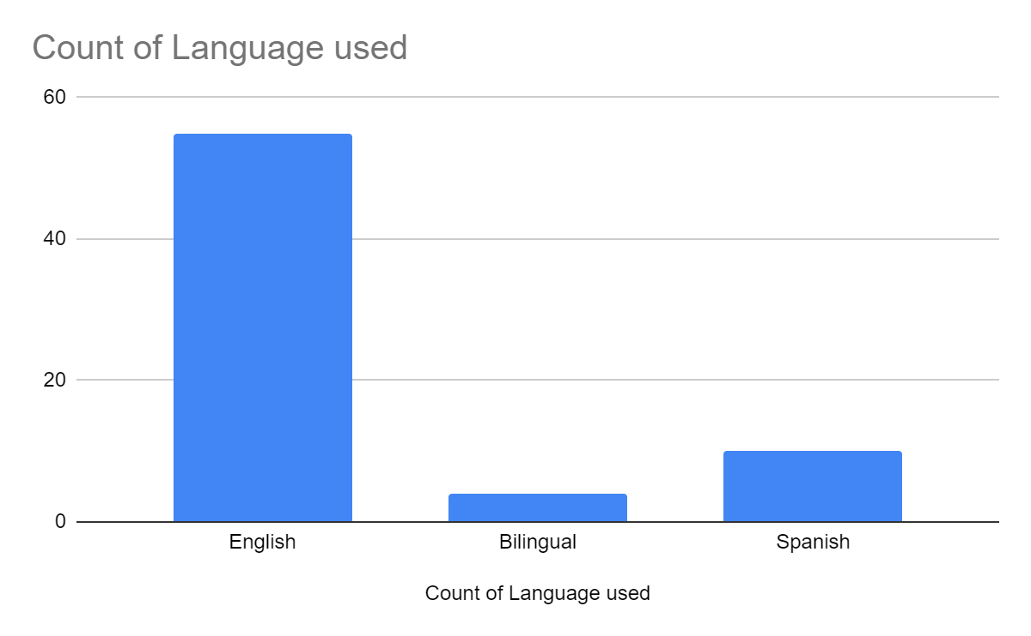
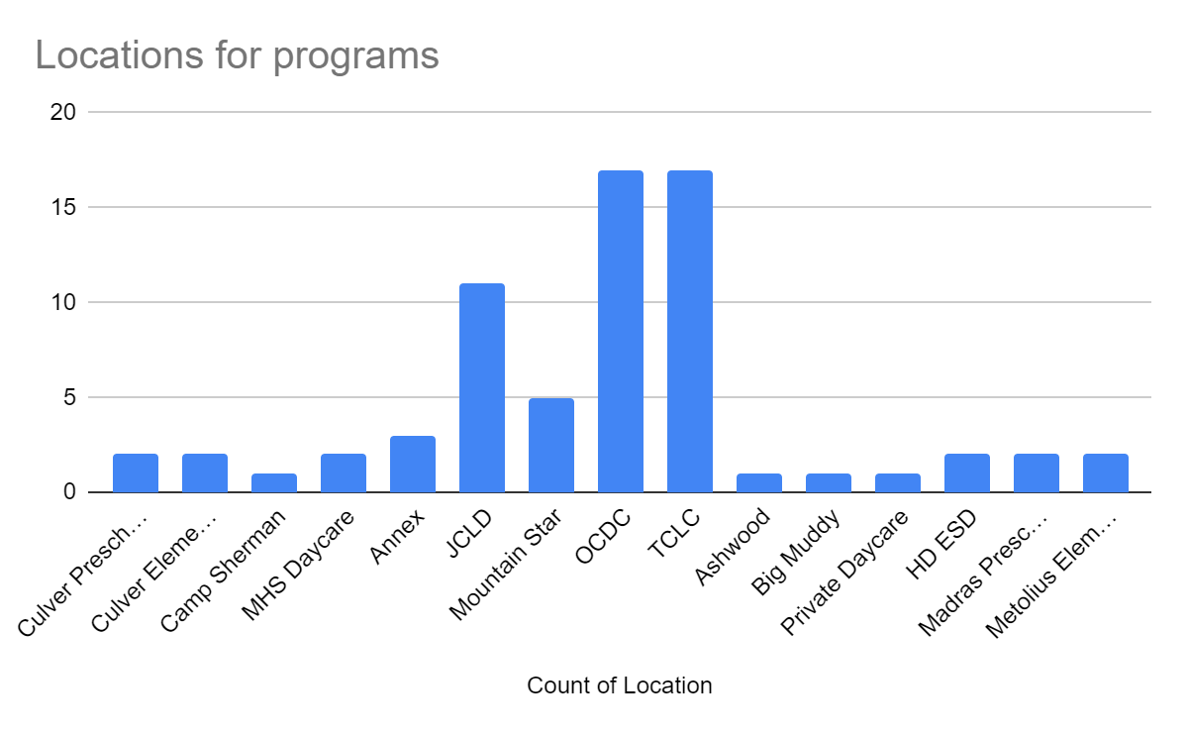
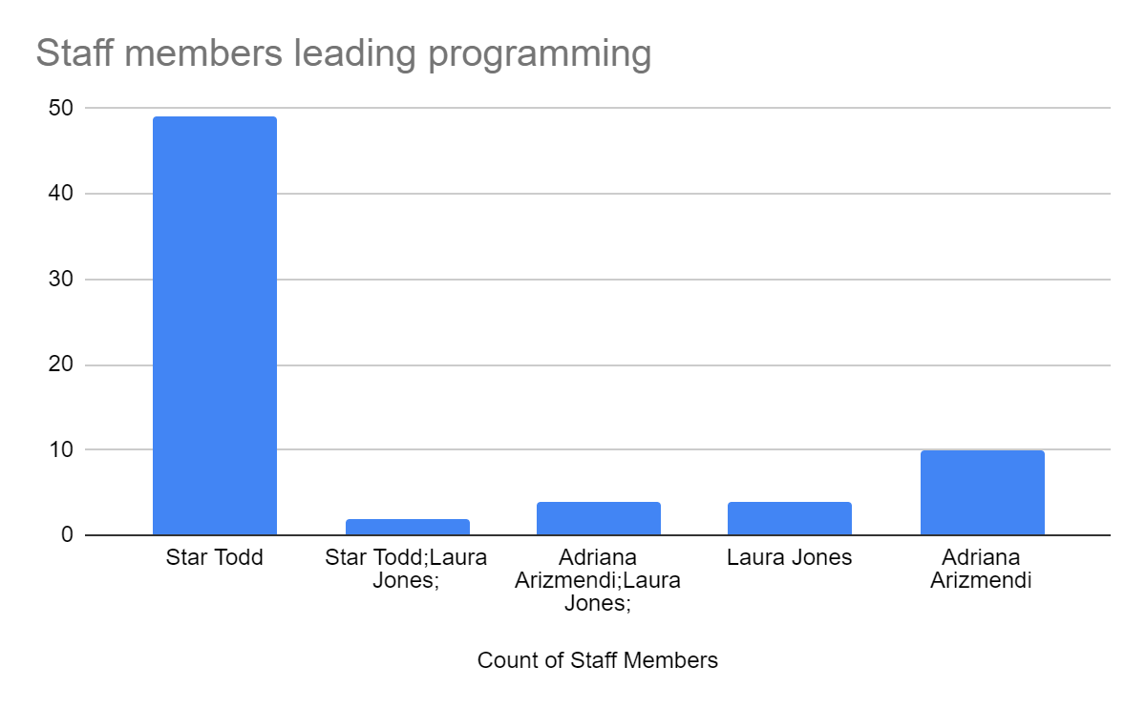
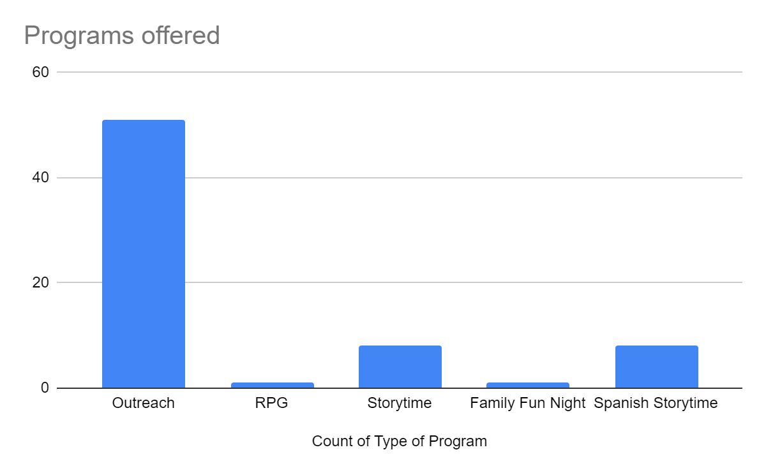
Technical Services – Jackie May
A total of 178 items were withdrawn from the collections, predominantly in the Juvenile section. Easy and Juvenile nonfiction, Easy Readers, and some Youth Graphic Novels were removed after evaluation, to make room on the library shelves. Also, a small amount of Adult fiction and nonfiction books were removed from circulation.
The interlibrary loan requests were down in February but have resumed steadily, beginning in March. The new processing system, set up by Gabrielle, for the backroom materials flow, has been working out very well. Gabrielle is very organized and has a good vision of how the material flow should occur. Kudos to Gabby!
February 2020 Stats
Bibs added: 77
Materials added: 306
Withdrawn items: 178

Interlibrary Loans:
From in state: 28
From out of state: 10
To other libraries: 0
Total: 38
Volunteer Services and RFID Project – Swan Liu
Volunteers
We have 12 regular volunteers, four smile volunteers, and one community service. One Smile volunteer has not been showing up regularly. Five applications are currently waiting for callbacks.
RFID
The RFID tagging is almost complete. There are only a few items returned each week that need to be tagged or encoded. Dion and I met virtually with the FE representative for console training and received follow-up documentation.
Circulation – Dion Hryciw
Statistics
Please Returns 18
Web Page 693
Internet 700
Door Count 3424
Facilities Report
- Security system installed
- Reinstalled the door counter
- Annex locks rekeyed
- Main library locks re-keyed
- Genealogy locks re-keyed.
- Genealogy back door secured and cleaned off.
- Library public bathroom locks replaced
- “Staff only” parking signs installed behind the library
- Furnace filters replaced
All Statistics are available for viewing in Smartsheet.

