Director and Department Reports
September 2020
Reporting on August Activities

Director’s Report
Covid-19 Update
We are currently wading through the process to create an account, so the Library can request reimbursement from the COVID Relief Fund. Special districts (as defined in ORS 198) outside of Multnomah and Washington Counties are eligible to apply for COVID-19 expense reimbursements. Approximately $17 million is available to distribute to special districts that apply. New rounds of funds will be available each month until November (possibly December), or until the $20 million is gone. We encourage you to plan now for what to submit.
Potentially reimbursable items
- UV-C lights
- Tables to accommodate social distancing at computers
- Chairs that replaced cloth couches
- Plexiglass
- Additional PPE
- Additional cleaning supplies
- Permanently mounted hand sanitizing station
- Increased janitorial/window cleaning costs
- Staff salaries, if what the staff was doing because of COVID, is different than the original position.
The staff is gathering COVID-related expenses, including PPE, some furniture, staff time spent on activities created because of COVID-19, increased janitorial costs, carpet cleaning, and so on. The next round of funding opens on September 14-21. At this time, we’re waiting for approval to access the CFR Grant Portal. Districts may submit a claim for eligible COVID-19 related expenditures from March 1st, 2020 forward in any reimbursement period until funds run out.
Audit Preparation
File transfer is almost complete. Amendments, resolutions, newspaper notices, the adopted budget, liability insurance declarations are ready. We still need to compile a list of donors who gave over $2000 in 2019-20, and whether any funds were restricted, a list of furniture or equipment we’ve eliminated or traded in, all of the grant award letters.
Board Policies
Grammatical corrections were made to the original document distributed at the August meeting. Included in your Board packet is a copy of the revised proposed operating policies, and a copy of the existing operating policies, for your review.
I plan to use the approved board policies to create administrative rules for any policy that requires one. I’m moving on to Personnel Policies next.
Personnel
Staff 1:1 meetings to follow-up on the mentoring sessions in June are mostly complete. Everyone was asked to provide a copy of a current resume, review the revised job description and sign, present measurable goals that both the staff member and director agree upon. All staff members have 3 or more goals in place. During follow-up meeting in January will be used to check on progress, identify challenges or roadblocks, and if necessary revise.
Facilities
Updates to the interior of the library continue. The Warm Springs school library is taking the current circulation desk sometime at the beginning of September and that will be replaced with something smaller. The logo wall should be complete by the beginning of September. The Annex has been cleaned.
Department Reports
Children Services
Librarians on the Loose took off this month with exciting numbers. Depending on the guest on Librarians on the Looks determined how popular the views were. While some percentages went down the videos watched are more active than the previous month. We also saw an increase in non-followers in viewing our content. They were invited to follow our page. Towards the end of September, we will reevaluate the program and see if it will continue through the Fall/Winter season. The Pioneer will run an article about Librarians on the Loose in September.

August 2020 Facebook
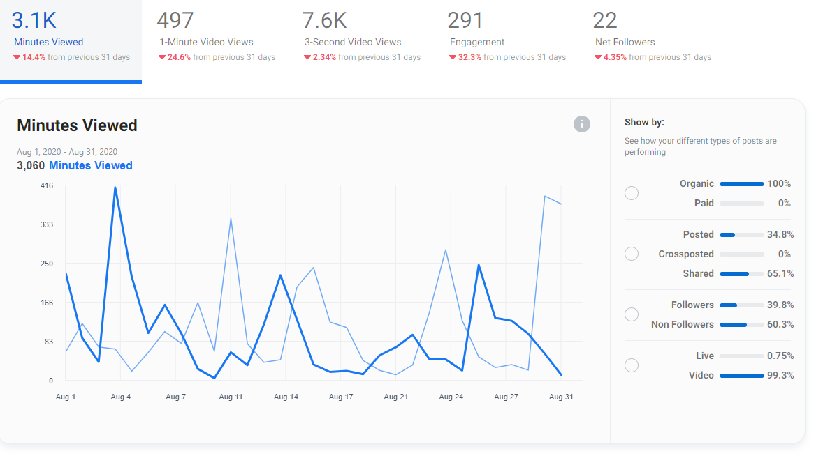

July 2020 Facebook

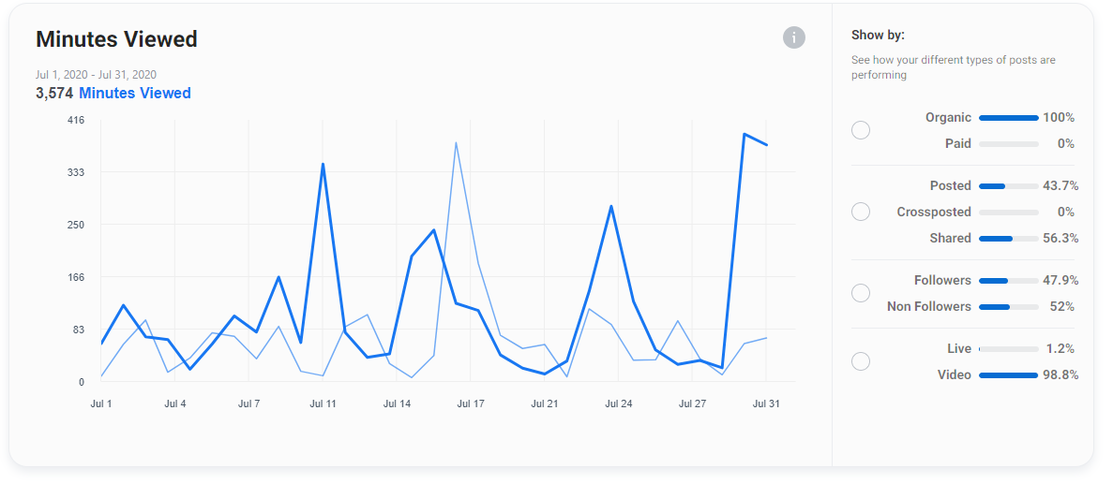

August 2020 YouTube
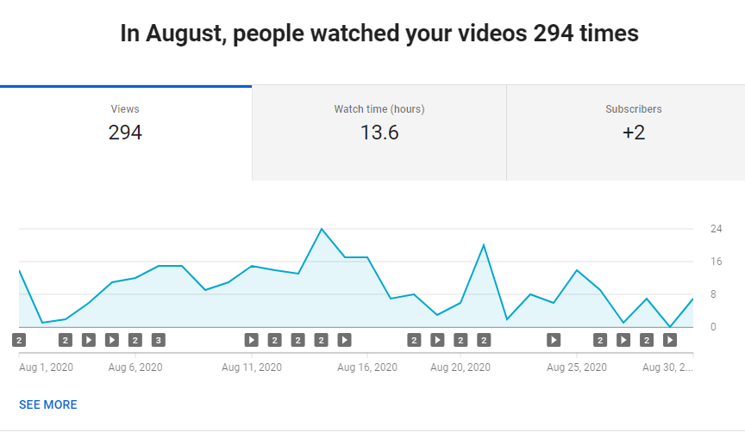
July 2020 YouTube
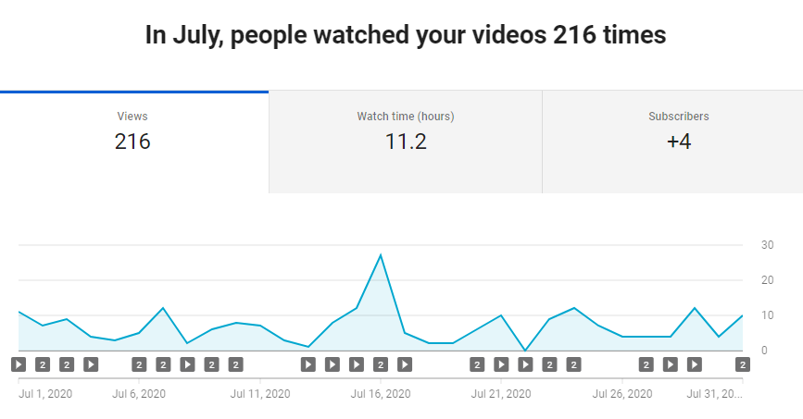
The Summer Reading Program ended on August 31. No more programs were offered but participants could continue reading and turn in their reading logs for the Grand Prize drawing. The stats for the Summer Reading Program began with 263 individuals registered and ended with 84 reading logs turned in for the grand prize drawing. There is a 32% retention rate. Reviewing the PLA Summer Reading Program evaluation retention rates are low and usually don’t go higher than 50%. Youth Services are looking for improvements for retention rates for 2021. There was an increase in Warm Springs K-8 Academy participation. There were 16 registered Warm Springs Students and 17 returned reading logs. This is a 106% retention rate. Currently, the focus for 2021 is outreach and increased retention for Madras, Metolius, and Culver.

KWSO Summer Reading Program Radio Program ended as well. It is difficult to calculate the stats for those who listened to the live radio program. We made a video program of each story and published them on both YouTube and Facebook. Combined they took in 711 views. We plan to continue this program next year.
August is the off month for programming due to families being on vacation. August is utilized as a planning month for the fall and winter programming. We have met and begun discussions on how to support the families and schools this year with the changes in education.

Circulation Stats
Total Registered Users 6563
Library Cards Issued 23
DPL items checked out at JC 427
JC items checked out at DPL 2774
CC items checked out at JC 72
JC items checked out at CC 144
Regular Circulation 2559
Renewals 300
Total Checkouts 5311

Volunteers
We currently have 3 adult volunteers working 8 hours a week and 3 teen volunteers working 4 hours a week. Staff is picking up shelving duties.

Community Services
The BookEnds Children’s Theater went well. There were 12 kids involved in the week-long camp and they all produced a play: What? The Forest. Each day they worked on skills, played games, and worked on writing and acting out their play. The kids helped paint the set, create the costumes, and gather props. They all had fun and one of the students’ said every day. “I am so glad I get to be in this camp. I am having so much fun!” The five adults who helped out: Gretchen and Laura from the JCL, Regina Macko, and two MHS grad and first-year college students Allison Turek and Torri Pha had fun too. “We were not sure what the kids would come up with but boy they did a great job. It was a lot of fun to see them play and their skills develop.” Gretchen stated. The play was filmed and aired on social media and the website because of government mandates on social gatherings.

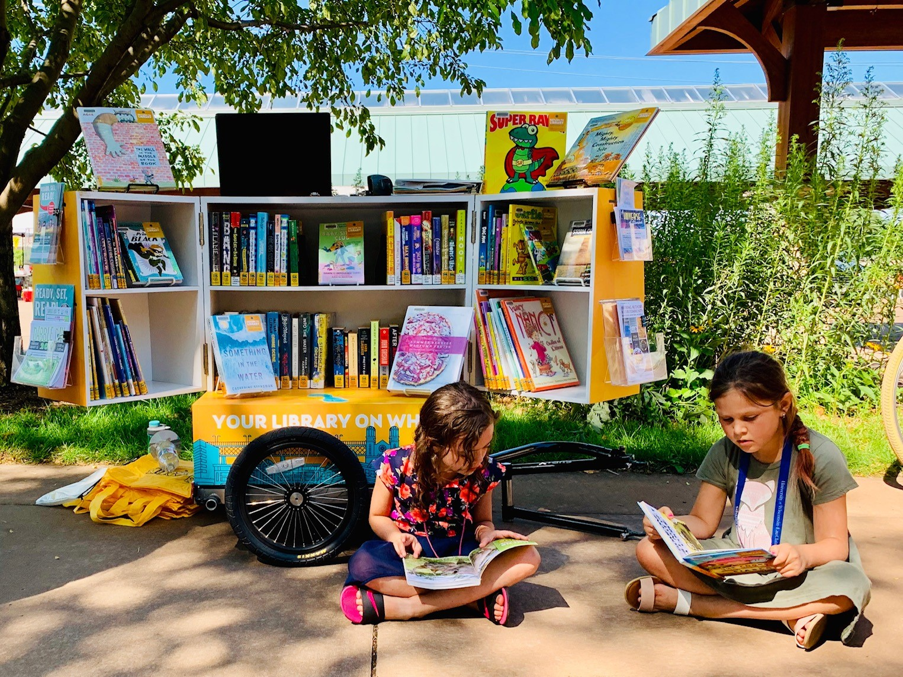
Feedback from the week was very positive and the call for more drama weeks was mentioned a couple of times.

Saturday Market: JCLD was present at all 5 Saturdays in August. We served over 300 people. A couple of weeks were slower than others. The Services Staff will review and form a strategy for Summer 2021 that allows more staff involvement. We are also investigating getting a small sandwich board made, rock weighs, and some moveable bookshelves for easier transport and faster set up.(Can we say Let’s go MOBILE!). We’re also hoping to add a mobile hotspot next summer.

The Website was re-organized and updated, plus we added an enhancement, Engage, which allows us to email patrons, staff, and other groups (like the Board.!) You should have received a test run email about turning in your bingo sheet. We were able to track who responded and field questions. This will be a useful surveying tool.

Gretchen started to deliver books to East Cascade again. We are using some large envelopes and quarantining books on both ends to make sure that we are practicing safe procedures.
Facilities
• Watered grass
• Rewired networking for copier & public printer
• Worked with Madras Computing to make the WIFI more secure.
• Worked with Madras Computing & Bend Broadband to boost WIFI signal in Annex.
• Helped move old metal desk out of Annex basement

After going through the closets and storage spaces in the Annex, we had a room full of old furniture, plus odds and ends, that we posted on social media for people to come and get. The items were offered for free with donations gladly accepted. Most of the items were taken and we received about $40 in donations. Included in the give-away were four wood tables ( hard to move out the way for activities and have long had loose legs that would not stay tightened). With these items gone, we can use more versatile folding tables that are stored off the main floor allowing more open space for activities.

Vinyl Signs: Star has been in contact with Brandon from RipQ in regard to the vinyl signage to be installed inside the Library on the big dark blue wall behind the circulation area. The signage is ready but installation is still waiting due to scheduling difficulties. RipQ is also making metal logo signs that will hang outside the Library, Annex, and the Heritage (formerly the Genealogy) Center. These must be installed by a company with a contractor’s license and have asked the City for a recommendation. If the Board has recommendations of a contractor that can install the exterior metal signs, please forward that information to star@jcld.org.

Friends of JCL
The FOJCL made 20 Grab N Go bags for distribution at the Saturday Market. All of them were gone by the end of the market. One lady mentioned that she had heard that the Grab-n-Go Bags were going to be at the market (Instagram) and she came down to get one. These are popular items.

The Friends Board met on the 26th to discuss the Annual Book Sale which has been moved to October to coincide with the Friends of the Library Week, October 18 -24. The board is new and it was the first meeting. The Board also discussed fundraising ideas and the logistics of running the Twice Read Books.
Genealogy
Approximately 13 linear feet of CDs have been reviewed, and about 1.6 linear feet will be kept. Those that were found to be unneeded will be recycled. A majority of the CDs reviewed required programs that are no longer current or available, or more records are available for free on the internet (Census, Vital Records, etc.). Those CDs kept included Jefferson County Cemetery Photos, an Index of the Oregon DAR (Daughters of the American Republic) Genealogical Reports, WWI Draft Registration for Oregon, Oregon Marriage Index 1925-1945, Oregon Heritage Press (assorted Oregon newspapers), The New England Historical and Genealogical Register (volumes 1-148, years 1847-1994 with index), personal histories by JBFF members, Resource essentials from Ancestry.com, Ancestry Magazine 1994-1999, Heritage Quest Magazine September 1985 - December 1999, and other miscellaneous records that Alex was unable to locate for free on the internet. The CDs to be recycled contained indexes to vital records and census records, while the index and actual records are available on Familysearch.org (for free) or Ancestry.com with more records available, and searching is easier than using the CDs.

Email was sent August 17 to Oregon Historical Society Museum Store (OHSMS) to enquire about their interest in our back issues of Oregon Historical Quarterlies as we will utilize the digital version available on JSTOR, allowing for easy retrieval and copying for our patron’s use. OHSMS is interested in accepting our Quarterlies as a donation, providing us with a letter acknowledging the value or our donation for tax purposes. We would need to deliver them to OHSMS in Portland.

Email was sent August 17 to Kelsey Perrigo, the Collections Care Manager at the A.R. Bowman Museum Research Library and the Bend Genealogical Society (BGS) as an inquiry in their possible interest in the materials that we will be removed from the collection due to our limited space and the items outside the scope of our collection development plan. Sandy Thompson, Treasurer for BGS, replied and is interested in helping in finding homes for the books we plan on removing from our collection. Sandy came by the Genealogy Center to see what we had, reviewing my selections and recommended creating a list of books we want to give away so she can review it for books BGS would like, as well as distributing the list to Bowman and other genealogy libraries in Eastern Oregon.

Email sent on August 17 to Jarold Ramsey from Jefferson County Historical Society (JCHS) to inquire about six books and 24 rolls of microfilm that we have that are on loan from them. Jarold Ramsey, a board member of JCHS, is happy for us to continue to house and steward the items we currently have on loan from them until they have their Museum and "Central Oregon Research and Archival Center" at Westside.

A location code for items housed at the Gen Cen was located in SIERRA (jmarg), and all 45 items have been identified and found.
ILLs
The Interlibrary loan requests increased in August. Staff investigated cataloging and ILL product improvements and changed our OCLC subscription from a transaction-based service to a cataloging/ILL bundle that includes other feature enhancements. The new service started on August 1, and so far, seems to have simplified several processes, especially for ILL fulfillment. Only one site is required to check for availability of materials. Once found, materials can be requested directly from the site, inputting various criteria for the source, and for our Library contact and mailing directions. We’ve transitioned to using stamps.com for mailing. All of these improvements have created a streamlined process that requires less manual searching, less manual requesting, and an online venue to check the status of your requests.
Teen Services
A teen party was held Saturday, August 1. The six teens attending appreciated having an event to attend. Loop-scarf style masks were given out at the door and individually packaged snacks were available. Activities included book nerd quizzes, button-making, bookmark-making, and rubber chicken catapult launching.
Safety Committee
Ongoing discussion for safe practices in the Library. Research into wall-mounted UVC lights for air sanitation to be possibly purchased with CARES reimbursement grant funds is in process. Considering applying for another matching (up to $2500) SDAO Safety and Security Grant this year to defray some of the costs of an AED.

