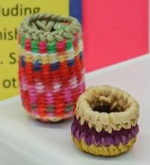
3 Sally Bags + Educational Poster

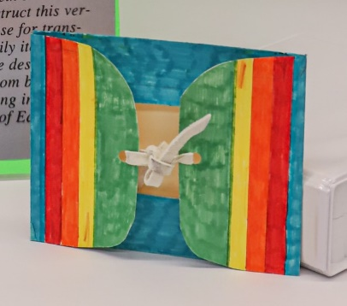
1 Indian Suitcase + Educational Poster
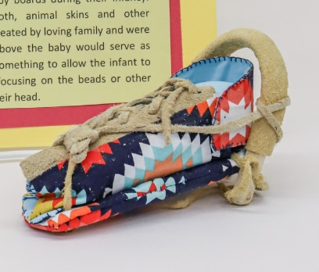
1 Cradleboard + Educational Poster
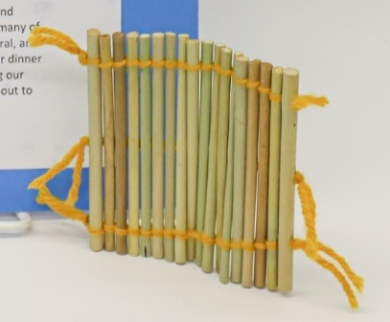
1 Tule Mat + Educational Poster

Confederated Tribes of Warm Springs Cultural and Heritage Curriculum Crate Contents
1 Flag
1 Tribal Enrollment Card
1 Tribal Sovereignty/Enrollment Educational Sheet
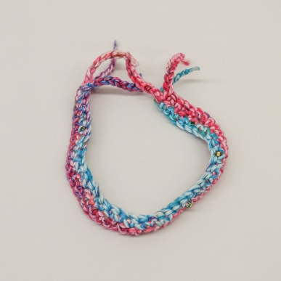
1 Yarn Belt
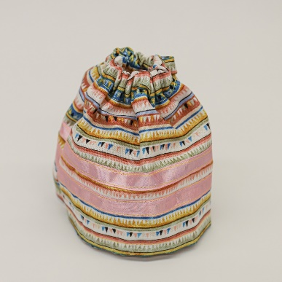
1 Ribbon Skirt
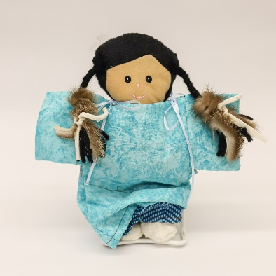
1 Doll
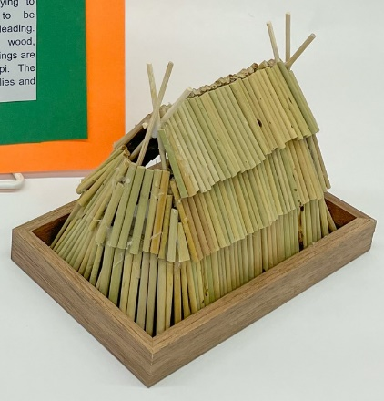
1 House + Educational Poster
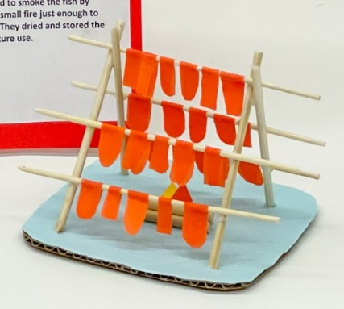
1 Fish Drying Rack+ Educational Poster
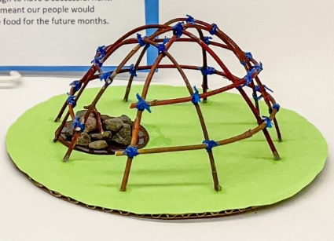
1 Sweat Lodge + Educational Poster
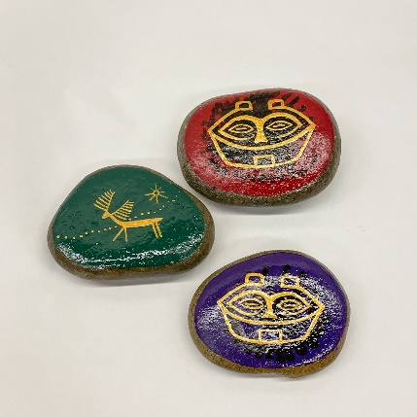
3 Painted Rocks

