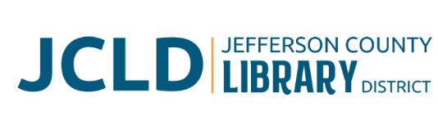
BOARD OF DIRECTORS MEETING
Monday, November 10, 2025 @ 4:30 pm
241 SE 7th St, Madras, OR 97741

Agenda
- Call to Order
- Acceptance of Agenda and Establishment of a Quorum
- Public Comment
- Presentations
- Review/Approval of Minutes – October 14, 2025 Board Meeting
- Finance Report
  - Monthly financials as of October 31, 2025
  - Grant updates
- Old Business
  - Building committee report
  - Update on Culver partnership project
  - Board evaluation
- New Business
  - Policy Monitoring
    - Governance: Board Members’ Code of Conduct
    - Board/Library Director Linkage: Unity of Control
    - Executive Limitations: Emergency Library Director Succession
- Library Activities Report and Update

- Ending Remarks

- Adjourn

