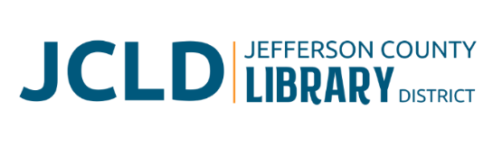

**BOARD OF DIRECTORS MEETING**

**Tuesday, October 14, 2025 @ 4:30 pm**

**241 SE 7th St, Madras, OR 97741**

**Agenda**

1. **Call to Order**
2. **Acceptance of Agenda and Establishment of a Quorum**
3. **Public Comment**
4. **Presentations**
5. **Review/Approval of Minutes** – September 9, 2025 Board Meeting
6. **Finance Report** 
   1. Monthly financials as of September 30, 2025
   2. Grant updates
7. **Old Business**
   1. Bookmobile Policy presented for approval
   2. Update on expansion plans and discussion with Owner’s Rep & Architect
   3. Update on Culver partnership project
8. **New Business**
   1. Policy Monitoring
      1. Governance: Chair/Vice Chair roles
      2. Board/Library Director Linkage: Monitoring Library Director Performance
      3. Executive Limitations: Financial Condition and Activities; Financial Planning and Budgeting
   2. Board evaluation
      1. Self-evaluation form
      2. Goal sheet
      3. Evaluation as per Governance Policy (Governing Style) - Once a year the Board will conduct a thorough evaluation to monitor and discuss its process and performance. Self-monitoring will include comparison of Board activity and discipline to policies in the Governance Process and Board-Library Director Linkage categories.
9. **Library Activities Report and Update**
10. **Ending Remarks**
11. **Adjourn**