Director’s Report – May 2020
Reporting on April 2020 Activities

Coronavirus Impact
Although the Library has been closed to customers since the middle of March, we are providing curbside checkout. We are preparing to schedule appointments for computer use, to address the needs of members of the community who do not have access to a computer. The computers are positionedd to maintain a safe distance between users. Staff will be disinfecting keyboards after each use. Curbside checkout has been steady, and to date, the team has served almost 200 individual checkouts, fielded book request calls, and general reference questions. The courier has been delivering every other Thursday. The Library is providing home delivery on request. From March 19-May 8 two staff members rotated Monday – Friday 10-3 for services. Beginning Monday, May 11, 3 staff members per day will be rotating Monday-Friday. The Youth, Children, and Spanish Services Department have been taping weekly storytime and book reviews.
At the last Tri-County meeting, Deschutes Public Library Announced it would begin Phase 1 (staff returns and returns are accepted twice/week) and Phase 2 (distribute hold items at curbside) of its reopening plan starting Monday, May 18. JCLD and Crook County have been accepting returns and distributing holds during the closure. Assuming it aligns with the Jefferson County Health Department guidelines and the most recent Executive Order from the Governor, our Library is planning on returning all staff on Tuesday, May 26, and will coordinate public opening with DPL. Crook County is required to adhere to County opening plans.
Facilities
With the Library closed to the public, it seemed like a good time to finish up painting projects. Repainting the public restrooms is in progress; removing the metal stall doors are is next. Since the restrooms have are now gender-neutral, one person uses them at a time, and there is no need for the metal dividers. By removing the dividers, it's one less thing to write on. We are also removing the bench in the Library foyer. The New Titles shelving and magazine shelving both look great and provide a less cluttered look in the adult area.
Web Site
With staff on an abbreviated schedule, it seemed like a good time to assign Web site content responsibilities. The Web hosting/support company dropped its data migration fee, and based on our annual budget; the monthly service fee is $100/month. The site architecture is completed (well as set as any fluid product can be), and designated staff members have been assigned content areas. Dion and Swan will be responsible for maintaining the general sections of the site, and each of the service/program departments will take over maintaining their sections. We have access to many databases through the statewide database purchasing program, and those will be linked directly from our Web site and include brief annotations describing the content. After considering adding Consumer Reports and Novelist, I decided against both in favor of adding the ProQuest Newspapers that enhance our new genealogy resources, and for the general public interest. By adding Chilton's online, we can get rid of the paper manuals (or store them, and the Children's Department is considering Tumblebooks. Alex Smiley has agreed to develop a reader’s advisory research guide to help customers (and staff) find new titles, authors, and genres.
Annex Update
Gretchen and Alex (our Annex Team) have reorganized the Annex basement. The Friends of the Library Twice Read Books are ready for viewing browsing. Alex is adding available titles to a free service, The Library Thing (https://www.librarything.com/), and when that is completed, we are posting a link on our existing and new Web site for people to browse and request titles. Another use for online catalog of FOL titles is for the Library staff to access when helping a customer look for a book that we don't have in the collection. You’ll find more information about the Annex transformation in the May Department Reports.
Director Projects
I'm still working on the projects listed below, and each is in various stages of completion. While reviewing policies might be exciting for some, I need to pace myself with that project. I'm having communication issues with one of the life insurance policy companies that are holding a gift to the Library, but I'll have that resolved before the next board meeting. The staff has reviewed existing job descriptions and offered updates and changes. I'm reviewing the suggestions and am scheduling 1:1 appointment with everyone that will wrap up before the end of the fiscal year. The Web site map is complete. I'm hoping that once our Board meeting returns to face-to-face, we can collaborate on identifying measurable goals for 2020-21.
Budget SWOT Analysis
The budget packet is complete; I've asked Mick to give it a brief review and I'll be distributing it electronically shortly. The State Library of Oregon is requesting all public libraries to complete the 157-question 2020 Public Library Standards Survey and return it by May 22. In reviewing the questionnaire, it seems to be a useful document to use to identify our Library's strengths and weaknesses. I will share the completed questionnaire with you when I submit it to the State.
Statistics
Of course, our statistics are way off from previous years for March and April and will be for May. Alternatively, the staff has been able to complete some time-consuming projects during the closure. Everyone is eager to come back to work.

Department Reports – May 2020
Reporting on April 2020 Activities

Adult Services – Gabby
Materials processing continues as we continue to receive new books. The installation of the slat wall is done and the new titles are in place. Next, I’m considering options to maximize the space between the slat wall and the foyer windows. Since most of the previous seating in the adult area has been removed I’m investigating options for new furniture. Although not directly adult services, I’m repainting the public bathrooms.
Annex Updates – Gretchen and Alex
Alex and Gretchen have totally reconfigured the basement space. The central gathering place is the same but they did swap out the three NW storage rooms for the Twice Read Books. They then reorganized the two storage rooms. The Old FOJCL office is now the traveling storytellers/Gretchen office space. The new FOJCL office/sorting room is the old hoarder room, which has been cleaned out and reorganized. There are still some shelves outside, if anyone needs them. Otherwise at the end of May- they will get torn down and sent to the dump.
I know this is the April update but since we have finished with the moving, Alex is heading up getting all the books available in Twice Read Books cataloged on The Library Thing. So if you would want to help scan. We have some “cat” scans and other equipment to do that.
Collection Development – Jackie and Alex
248 new items were added to the collection in April. Updating the spine labels for the audiobook collection is ongoing, with approximately 75% done.
Community Services – Gretchen
There are still no programs or classes happening. So much of my time has been working on future projects like the Adult Summer Reading Program, and planning crafting ideas for July-June.
I’ve contacted the three city halls in the county to discuss Free Little Library opportunities. As you know, the Community Read event that usually happens in April, was postponed. The plan is to reschedule it for early October (after the fall school rush and before the holiday madness). The committee will regroup with social distancing allows. Finally, I’m working on book club collections and community read ideas for 2021. Using Friends of the Library book inventory, I’ve created Grab-n-Go bags (books and movies with a theme) now I need to advertise its availability. Cancelling the weekly Chamber of Commerce Coffee Cuppers event has limited my community word-of-mouth advertising.
Shutdown Maintenance – Roy, Gabby and everyone else
Figuring out how to create space in the rear of the building for ads and PSAs, since there’s more activity in the library alley. Also finding a better place for the sign at the corner of the 7th Street and E Street intersection.
Youth/Children/Spanish Services – Star, Laura, and Adriana
Online Storytime/Programming continues to be popular. Here is our current schedule for releases:
- Mon 9:00 Miss Star (Traveling Storyteller) story
- Mon 5:00 1-Minute Young Adult Book Review
- Tue 10:00 English Storytime
- Wed 1:00 Spanish Storytime
- Thu 10:00 Bilingual Storytime (most popular)
- Fri 5:00 Weekend Challenge
The weekend challenge focuses on a different family activity. Past activities: going on a bear hunt, Easter egg hunt, get caught reading, surprise Mom with flowers. If you haven’t checked out the JCLD Facebook page, we encourage you to do that and view some of our online story time presentations or book reviews.
Video Storytime Statistics

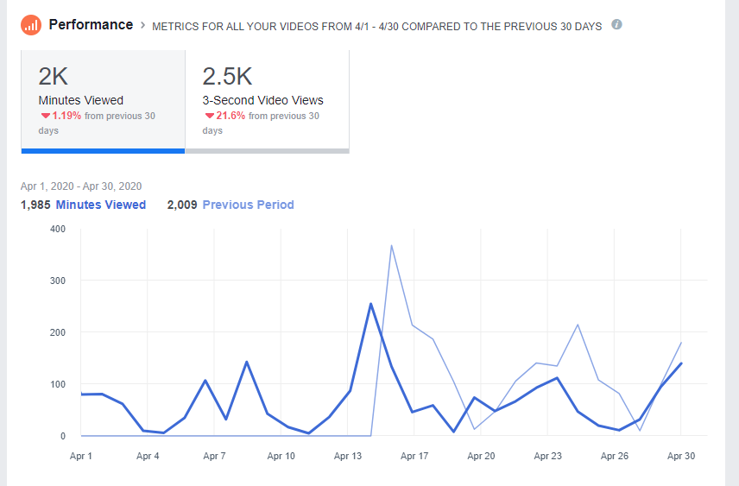

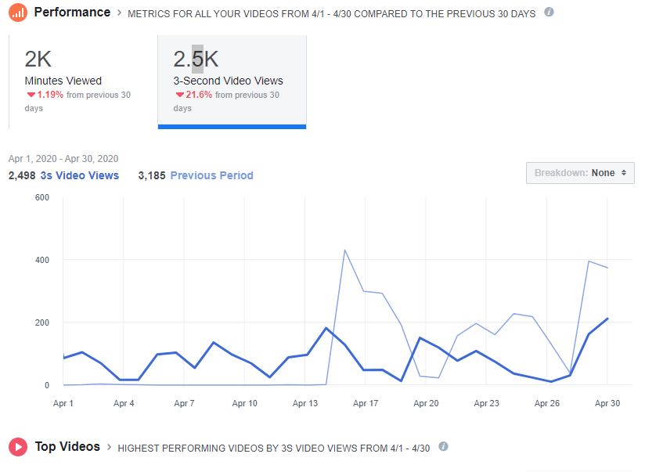
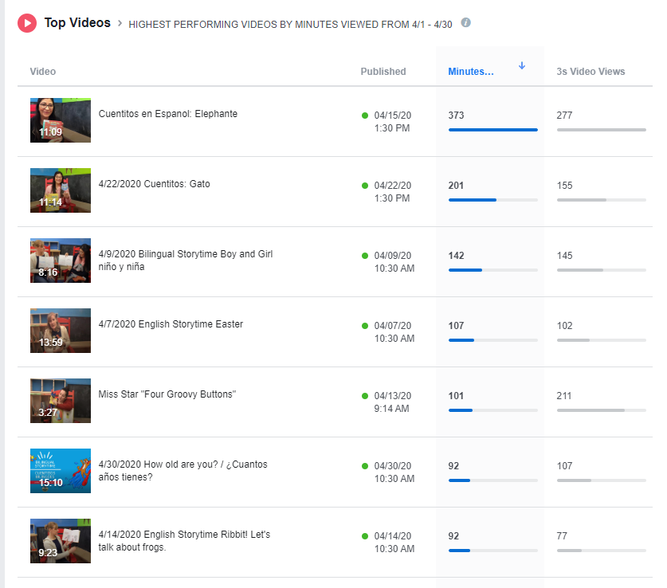

Our online storytimes continue to be a success and draw viewers from inside the County, other states, and Mexico. Laura and Adriana have been watching the statistics. Bilingual Storytime and Spanish storytimes are doing quite well and are the most viewed. Laura and Adriana are collabrating in transitioning to creating more bilingual content for future online programs and are providing bilingual Summer Reading as well.
The Teen Role-Playing Group has also had two online sessions, once over Zoom and once with a Virtual TableTop (VTT) website. The second format was a better solution but will need refinement. We’ve lost some attendance this way, but those still playing have enjoyed it. There will be one more session in June, at which time we will break for the summer.
The Youth Services team has been hard at work to reformat the Summer Reading Program. The new format will have two prongs. The first is an online component. This will involve a weekly storytime program with challenges. It will also have an online registration for logging reading to enter for grand prizes. The second prong will be to partner with the school to send out reading logs and craft kits via free lunch sites. We have already contacted 509J to facilitate this. They are open and enthusiastic and have already been sending out craft kits using a grant they acquired. It will run out in June and then we will pick up. We have changed the book give-away from the last program to the first to ensure kids have a book in their home. This rework of the Summer Reading Program has doubled the projected cost of the program. We are working to look for additional funds and borrow funds from other budget line items.
A partnership with KWSO is also in the works. We have been in contact with Sue Matters and are working on doing a daily 3-minute segment for eight weeks in the summer reading a story and promoting reading and the library. We are fortunate to have Gena who works at the Warm Springs K8 Academy and has helped us to have more intercourse with Warm Springs. She has also taken some of the withdrawn Youth materials to Warm Springs to be sent out via the bus routes. 509J is sending out free lunch/breakfast/dinner once a week along the bus routes for free lunch sites in the more remote parts of Warm Springs.
Laura is continuing to improve the “J” section (2nd-8th grade). Last year we started with a color-coding system to clarify the different youth sections. Progress is almost complete. Star completed all of the “Y” (teens) section and it is coded as light blue. The “E” (infant-1st grade) is red/bright orange. Picture books are categorized according to subject with a color-coding system as well. This project improves efficiency in locating and shelving. We also hope to see a decrease in mishelving.
Spanish Services have been recording videos to Facebook and Youtube in Spanish and Bilingual Story-time with Laura. During the month of April I had the opportunity to see some online conferences as well as job security, shared by Jane. Some preschool teachers have contacted me to access the library books, so I have provided them with books every week, so in one way or another the Spanish collection has had rotation. I have also asked them to tell their friends, teachers, co-workers and family, so that more of them can call the Library or me to check out books.
With the current conditions, we have been in communication with Laura and Star for the planning Summer Reading Program in English and Bilingual 2020. I inform you that Cuentitos en Espanol will join the bilingual stories under the circumstances. Of course Jane is informed how the SRP will be.
Finally, the Spanish collection continues to be labeled as well as I have been removing old tags that said "new" that the books had.

