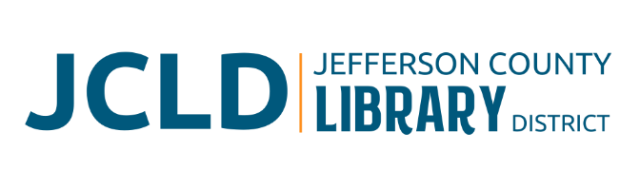
BOARD OF DIRECTORS MEETING
Tuesday, August 13, 2024 @ 4:30 pm

Minutes
Board Present: Susan Stovall, Tiffany Turo, Tess Ballard, Karen Esvelt, Stephen Hillis
Staff Present: Jane Ellen Innes, Laura Jones, Gabrielle Beebe

1. Call to Order
Susan Stovall called the meeting to order at 4:31 pm

2. Acceptance of Agenda and Establishment of a Quorum
A quorum was present. Stephen Hillis moved, and Karen Esvelt seconded to accept the agenda with flexibility. The motion passed unanimously.

3. Public Comment
None.

4. Presentations from Outside Groups
None.

5. Review/Approval of Minutes – July 23, 2024, Board Meeting
Karen Esvelt moved, and Tess Ballard seconded to approve the minutes as presented. KE/TB

6. July Finance Report
Hillis moved, and Tiffany Turo seconded, to approve the July Finance Report as presented. The motion passed unanimously.

7. New Business
None.

8. Library Activities Report and Update
A. PGE Tax Roll Correction

Background
Innes shared that on July 17, 2024, the County Assessor confirmed a 2023-2024 tax roll correction that will also affect the 2024-2025 tax roll collection. The Library District must reimburse PGE for its miscalculation/overpayment of $55,000 plus interest. Several days later, a second notification clarified Oregon State Law requiring all entities in the taxing District to reimburse PGE, regardless of whether they received utility roll tax from PGE. While that reduced our liability to approximately $42,000, including interest, others who received no PGE utility roll funds must contribute to the tax roll correction. The effect on the 2023-2024 and 2-24-2025 budgets is a combined $84,000 - $110,000 decrease, which includes paying back funds received last year and reducing our JeffCo tax projection by the same amount.

Discussion
Jane Ellen and Kristin checked in with Mick about how to mitigate the impact of losing $40-50,000 received in the 2023-2024 budget year and the impact of not receiving $40-50,000 in anticipated revenue in 2024-2025.

Potential cuts from the 2024-2025 operating budget:

Reduce Salary Increases/PERS/Payroll Taxes 13,315.00
Tuition Reimbursement 10,000.00
Vehicle Maintenance 1,000.00
Marketing 2,000.00
Telephone 480.00
Travel/Training 4,700.00
Patron Materials 9,500.00
Library of Things 1,000.00
Program Expenses 4,500.00
Databases 4,050.00

The board discussed the impact, timeline, and potential funding sources.

9. Ending Remarks
There is no meeting in September.

10. Adjourn
With no further business before the board, the meeting adjourned at 5:28 pm. The next Jefferson County Library District meeting is Tuesday, October 8, 2024.

Respectfully submitted,

Jane Ellen Innes
Secretary to the Board

