Director and Department Reports
July 2020
Reporting on June Activities

Director Report
Marketing and PR
The new Web site was launched on June 1; staff continues to tweak it based on customer feedback. The online databases are all working, and we’ve added the genealogy databases Ancestry.com, HeritageQuest, and Fold 3. Ancestry.com is only available in the Library. The other two are available in the library or online. In the next month or two, the Genealogy Center IP address will be added to the subscription and all three will be available there as well. So far, one research guide, Genealogy, has been created. The staff is starting to think about additional topics. I’ll be compiling health information resources, and business and finance. I’ve asked other staff to identify areas of interest and start a research guide. Each guide includes: where to find the information in the library – e.g., call numbers, relevant journals, especially those included in RBDigital, relevant Library databases, and other reliable Web sites.
Our vinyl and metal signs have been ordered (RipQ). Metal signs will be installed outside at the main library, Annex, and Genealogy Center. We’re in the process of getting sign approval. Vinyl signs will go on the wall behind the circulation desk, and on the outside drop box. We have temporary signage in the library that will be replaced with permanent signs. To comply with the mandate that masks be work in all public places, nside signs have been placed on the door to the workroom, director office, and youth services office, identifying all three as private spaces.
Gretchen and I went to the Chamber Cheer event at the Madras Garden Depot at the end of June and plan on attending any upcoming ones.
Human Resources
All of the position descriptions have been revised and are included in the Board Packet. I met with most staff during the last week in June for coaching sessions. Relevant forms are attached. I asked everyone to review the last year and identify (1) accomplishments, (2) challenges, (3) Personal Growth, (4) Career Aspirations, (5) SMART Goals for the 2020-21 year. Follow-up meetings will be scheduled for the end of July, when each team member will present his/her finalized summary that includes SMART goals and specific steps for reaching the goals, offer any corrections/ additions/updates to the revised job description, and a resume. All items will be included in the permanent personnel file. I’m planning a mid-year check-in in January 2021.
Budget
The Budget Committee met for the final time on Wednesday, June 3. In addition to a quorum of the committee, Mick Knobel was also present. After reviewing the revised budget, the Budget Hearing was scheduled for Tuesday, June 23, 2020. The Board met directly after to accept the budget and pass the annual resolutions.
Adult Services/Community Services (Gabby & Gretchen)
Gretchen has been working on the Story Book Walk event for most of the month. We are planning to have it in three locations. At the Sahalee Park on July 11. Culver School on July 15 and during the Metolius Community Picnic on July 18th. Mail Copies and More will print up the station signs. There was a grant that the Children’s dept received that will help to pay for those signs.
Jane Ellen and Gretchen had a meeting with the leadership of AA and NA to explain the new guidelines for use of the Annex. The new rules and expectations were well received. Hours and availability of the downstairs meeting room continue to change as we expand our service hours. It was explained that no permanent storage was allowed in the Annex; the new cleaning protocol, that follows the OHA and the COVID 19 procedures, was explained.
Gretchen is preparing for is the BookEnds: Madras Children’s theater summer camp. This camp will be held from July 27 to August 7. The first week is for younger kids, the second week is for older kids. The week will be spent learning public speaking and drama skills. There will be a performance night on each of the Fridays, most probably in the Annex parking lot to allow for social distancing. This camp idea came from the JCLOperettas performed in the 1930s.
Gabby finished the public restroom update.
Adult materials were ordered and cataloged.
There was a writing competition on the Facebook page (no staff or family could participate – bah).
The genre for the Online Book Club on Facebook was “travel.”
Laura and Gretchen staffed a library booth at the Saturday Market. The first week (7/13) Laura had the Boy Scouts help with setting up and taking down. She handed out a lot of books and got kids informed about the SRP. The second week (7/20), Laura and Gretchen handed out books and prizes; 93 people stop by the tent. Jane filled in on the June 27 (she forgot to count people).
Friends of the Library
The FoJCL had a paperback sale on June 13. They raised $560 and had 93 customers. One elder lady (91) came and bought 145 paperbacks. A number of customers mentioned that they did not know there was a book room in town and were excited that there was a place to come and buy books now. Most of the customers were impressed with the organization and selection. One lady stated, This is like Christmas for me! Another customer commented that he was glad he did not have to go to Bend to get books and he liked the prices too!
FoJCL would like to have the Twice read Books open more often and is actively searching for a community member interested in running it.

The Friends has three new board members, Joan MacDonald, Amy Oland, and Shea Shirling. Unfortunately, all work during the day, and are unable to help with TRB during the week
Four new volunteers that helped set up, take down, and run the paperback book sale on Saturday 7/13. Two of them were new board members. The third new board member was at graduation.
There were 25 Grab and Go bags put out during the sale; by the end of the day only three remained. The bags generated quite a bit of excitement. To date, we’ve created 58 bags and 55 have been taken. (The Friends needs to make more!)
One of the issues that FoJCL and JCL need to address is how to get people to understand donations and donation times. We had about 90 books dropped in the Library’s return dropbox and three boxes left by the back door of the Library. We need to get the word out more about when and where to bring donations, and what we take.
June Circulation Statistics (Alex)
- Total Registered Users 6723
- Library Cards Issued 18
- DPL items checked out at JC 321
- JC items checked out at DPL 2134
- CC items checked out at JC 53
- JC items checked out at CC 86
- Regular Circulation 2310
- Renewals 113
Total Checkouts 4265
Cataloging and ILL Statistics (Jackie)
The month of June brought a few more Interlibrary loans from customers, as outside libraries opened up once again. We have discontinued the use of the ORBIS courier system through UO, the tri state courier route for academic libraries and public libraries to send materials to each other. The cost of using this system was becoming a bit expensive and other options are available. Instead of going to the post office, the new Stamps.com scale and label printer are housed in the back room and the software is installed on Gabby’s and Jackie’s computers.
Now we can weigh and mail packages, large envelopes and letters without having to make a trip to the post office, and have the interlibrary loans packages ready for the mail carrier to pick up from the library. This should save some money and time. Whereas the ORBIS courier arrived two days a week, the Stamps.com option is available Monday through Friday.
Cataloging
- Materials Added 553
- Bibs Added 239
- Spanish Materials Added: 88
- Items Withdrawn: Statistics unavailable
InterLibrary Loan
- From out of state 2
- From in state 8
- TO Other Libraries 0
Total 10
Proctoring 0
Youth Services (Adriana, Laura, Star)
Summer Reading Program (SRP) kicked off with a Challenge to register and pick up their 1st Craft Kit. Our first kit drop-off at the free meal sites, we gave away almost 500 craft kits and registered close to 200 youth. The craft kits were filled with informational flyers about SRP and a fun craft. The chart below demonstrates the percentage of which schools the youth who registered attended during the 2019-2020 school year. Some schools are not listed. Each school in 509J and Culver are represented on the graph.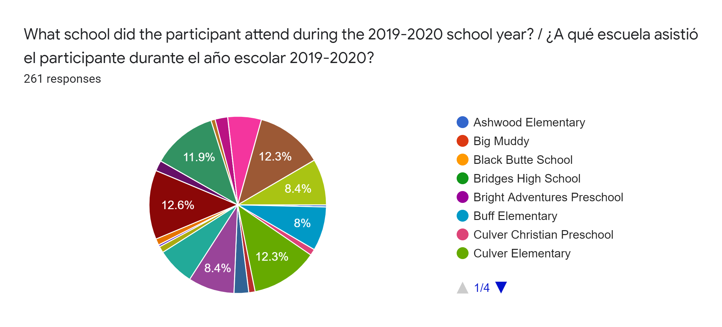
With COVID 19, we had to switch to a limited physical contact program. The cost of switching to an online and give-away program became greater than our budget. We secured a grant from the Institute of Museum and Library Service (ILMS) through their COVID 19 Response Grant and received monies from the Jefferson County Library Endowment. With the increase of funds, we purchased more supplies and equipment to improve the programming. We improve the quality of the craft kits and online programmings such as Bilingual Storytime, SRP Weekly Challenge, and Performers. We purchased the needed equipment and software to provide a clearer image and improved sound for all videos.
Craft kit numbers began to drop off by the end of June for the Madras area. The drop off was caused by the end of the school year and the parents not needing to turn in their children’s schoolwork. Warm Springs kit numbers remained steady as well as Culver. In fact, in the images below, Warm Springs began to increase in number of Craft Kits going out. Culver took a drastic dip over the 4th of July weekend which was expected to happen.
The demand for a larger outreach program for the Summer Reading Program has stretched the budget and the staff hours. The Youth Services Team has logged a lot of unpaid overtime hours just to meet the demand. Our services for outreach included free meal sites location Craft Kit drop off, visiting schools, meeting with school leaders and performers, preparing kits, creating online programming, filming and editing all online videos, managing the Saturday Market booth, participating in the KWSO. The comments from the community are encouraging and appreciative of our efforts. Many both school leaders and community ask if we will continue to provide programming such as this next year for the Summer Reading Program.
2019 SRP vs. 2020
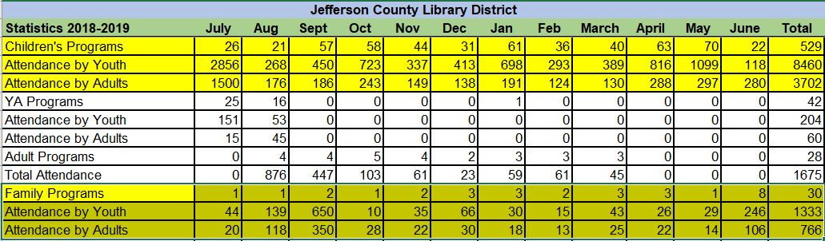
Total attendance in June for two Summer Reading in house programs 246 youth and 118 attending storytime.
Summer Reading Program June 2020
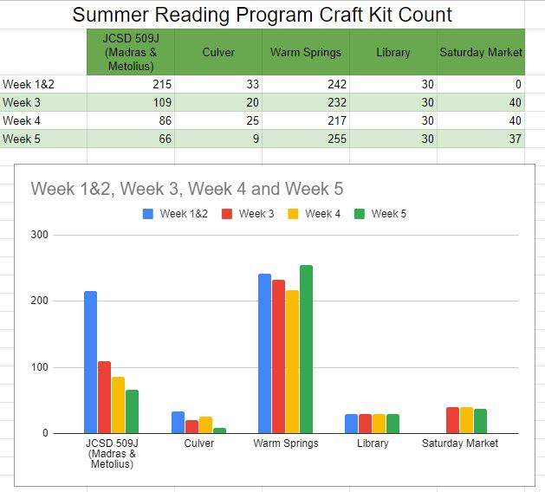
Total SRP Craft Kits 5 Weeks from June 1st - July 4th is 1,746.
Facilities and IT (Dion)
Performed a perimeter check of both the main library and the annex. Reviewed the sprinkler system and replaced the one faucet that was broken. Arranged for motion lights to be installed around the Annex and the alley between the Annex and the Library (scheduled for July 13). Two Motion lights for the Genealogy Center will be ordered next month. One of the internal office doors was locked accidentally and while keeping the spare key in the cash register used to work, when the register is located in the locked room, it’s a problem. After calling the locksmith to open the back office, removed the spare key from the cash register and stored it outside of the back room. As the beginning of the next fiscal year approaches, I collaborated with a representative of Madras Computing to figure out our existing computer inventory and consider purchases for FY 2020-21 and beyond.
Safety Committee (Swan, Star, Gabby)
.

