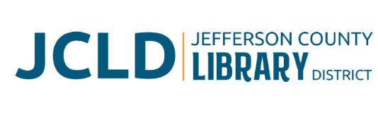
BOARD OF DIRECTORS MEETING
Tuesday, October 14, 2025 @ 4:30 pm
241 SE 7th St, Madras, OR 97741

Agenda
- Call to Order
- Acceptance of Agenda and Establishment of a Quorum
- Public Comment
- Presentations
- Review/Approval of Minutes – September 9, 2025 Board Meeting
- Finance Report
  - Monthly financials as of September 30, 2025
  - Grant updates
- Old Business
  - Bookmobile Policy presented for approval
  - Update on expansion plans and discussion with Owner’s Rep & Architect
  - Update on Culver partnership project
- New Business
  - Policy Monitoring
    - Governance: Chair/Vice Chair roles
    - Board/Library Director Linkage: Monitoring Library Director Performance
    - Executive Limitations: Financial Condition and Activities; Financial Planning and Budgeting
  - Board evaluation
    - Self-evaluation form
    - Goal sheet
    - Evaluation as per Governance Policy (Governing Style) - Once a year the Board will conduct a thorough evaluation to monitor and discuss its process and performance. Self-monitoring will include comparison of Board activity and discipline to policies in the Governance Process and Board-Library Director Linkage categories.
- Library Activities Report and Update

- Ending Remarks

- Adjourn

